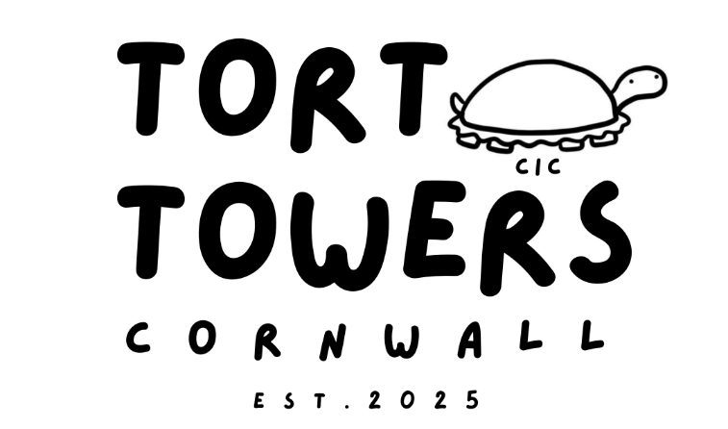



REHOMING/ADOPTION APPLICATION

Thank you for your interest in adopting a tortoise from Tort Towers Rescue CIC. Our priority is ensuring that every tortoise in our care transitions into a safe, species-appropriate, lifelong home.
Important Application Guidelines
- Mandatory Photos: Applications will not be processed without clear photographs of both your indoor and outdoor setups.
- Age Requirement: Applicants must be 18 years of age or older.
- Waitlist Policy: Submission of an application places you on our rehoming waitlist. Approval does not guarantee immediate placement, as matching depends on species availability and suitability.
- In-Person Collection: If approved, you must collect the tortoise in person. We do not permit animal couriers.
- Vivariums & Glass Tanks: Tort Towers Rescue maintains a strict policy against housing tortoises in vivariums or glass fish tanks.

Section 1: Applicant Information
- Full Name: ___________________________________________________________
- Address: _________________________________________________________
- Telephone Number: ____________________________________________________
- Email Address: ________________________________________________________
- Are you over 18 years of age? [ ] Yes [ ] No

Section 2: Adoption Preferences & Background
- Species Preferred: ____________________________________________________ (e.g., Hermann’s, Horsfield’s, Spur-Thighed, Sulcata, Red-Footed, Open to Any)
- Specific Tortoise Name (if currently listed): ________________________________
- Previous Tortoise Experience:
  - [ ] Experienced owner (Current/Previous)
  - [ ] First-time owner (Research completed)
- Research & Knowledge: If you are a new owner or adopting a new species, please detail the research you have conducted regarding species-specific husbandry and diet, requirements:

Section 3: Existing Pets & Quarantine
- Do you currently keep other tortoises? [ ] Yes [ ] No
  - If Yes, please detail species, sex, approximate age, and current enclosure set-up:

- Do you have other household pets (e.g., dogs, cats)?
  - [ ] Yes [ ] No (If yes, please list species and security precautions taken to keep tortoises safe):

- Quarantine Agreement: Do you agree to keep any newly adopted tortoise strictly quarantined from existing tortoises for a minimum required period? [ ] Yes [ ] No

Section 4: Housing, Setup & Hibernation Planning
- Indoor Housing Setup: Describe enclosure type (e.g., Tortoise Table, Open-Top Box, Greenhouse), substrate, dimensions, and heating/UVB lighting equipment used:

- Outdoor Housing & Grazing: Describe outdoor pen dimensions, boundary security, predator protection, safety, and shelter facilities:

- Diet & Nutrition: Outline the planned daily diet and dietary supplements (e.g., calcium, Vitamin D3, weed species, cuttlebone):

- Hibernation Knowledge: For species that require hibernation (e.g., Mediterranean / Horsfield's), describe your plan or experience with safe hibernation procedures:

- Photo Verification Enclosed?
  - [ ] Yes, indoor setup photo attached
  - [ ] Yes, outdoor pen photo attached

Section 5: Veterinary Care & Welfare Acknowledgment
- Specialist Veterinary Access: Reptile care requires specialist exotic veterinary attention, which can be costly. Do you confirm that you have access to a qualified exotic vet and possess the financial means to provide medical care when needed?
  - [ ] Yes [ ] No
- Preferred Exotic Vet Practice: ________________________________________

Section 6: Future Availability & Waitlist Data Consent
- Application Retention: If a suitable tortoise is not currently available, would you like us to retain your application on file for future rehoming considerations?
  - [ ] Yes [ ] No
- Additional Comments / Supporting Notes:

Section 7: Terms and Conditions of Adoption
Please read and initial each point to confirm agreement:
- Species Separation & Group Dynamics: Different species must never be housed together. Grouping same-species tortoises requires suitable male-to-female ratios (minimum 1 male to 2+ females, species-dependent) to prevent aggression. ____ (Initials)
- No Breeding or Commercial Use: Adopted tortoises are for companion purposes only. You agree not to breed, sell, or commercially exploit any tortoise rehomed from Tort Towers Rescue. ____ (Initials)
- Surrender Back Guarantee: If you can no longer care for the tortoise, you agree to return it directly to Tort Towers Rescue CIC. You must not rehome, sell, or pass the tortoise to a third party. ____ (Initials)
- Welfare & Inspection Rights: Tort Towers Rescue reserves the right to review animal welfare and reclaim any rehomed tortoise if care standards fall below accepted animal welfare guidelines. ____ (Initials)
- Enclosure Criteria: Tortoises will not be rehomed into vivariums or glass fish tanks. ____ (Initials)
- Health Acknowledgment: Rescue tortoises undergo monitoring, but non-symptomatic conditions can exist. Tort Towers Rescue will never knowingly rehome a sick tortoise, but cannot guarantee long-term health post-adoption. ____ (Initials)

Section 8: Support & Voluntary Donations
Tort Towers Rescue CIC does not charge mandatory adoption fees or membership subscriptions. We are against the commercial importation and exploitation of tortoises.
We operate as a small, non-profit rescue in the Southwest relying on public support. Voluntary contributions directly cover medical bills, rehabilitation, food, and rescue operations.
- PayPal: torttowers@gmail.com
- Direct Bank Transfer (BACS):
  - Account Name: Tort Towers Rescue CIC
  - Sort Code: 82-12-08
  - Account No: 70014070

Section 9: Declaration & Submission
I confirm that all information provided in this application is accurate and complete to the best of my knowledge. I have read, understood, and agree to the Terms and Conditions listed above.
Applicant Signature: ____________________________________
Date: ________________________

Return Instructions
Please email your completed application alongside setup photos to:
- Contact: Jade Webb
- Email: torttowers@gmail.com

